**IC EX 6A: Assignment 6**

Read the article on IPv6 timelines:

http://ipv6.com/articles/general/timeline-of-ipv6.htm

Write one paragraph summarizing the advantages of IPv6

Write one paragraph addressing the timeline for IPv6 and the apparent schedule slip that has occurred in the deployment.

Include a proper APA citation for the article and you may include other citations if you wish to.

*The IPv6 protocol is the solution developed to phase out and supplant the IPv4 protocol and offers an increased and improved addressing capacity to handle the explosive, expanding usage of the Internet. It is more efficiently processed at intermediate routers. Its larger address space allows multiple-levels of subnetting, which obviates the need for address-conversion techniques. It has a hierarchical addressing and routing infrastructure to be efficiently processed by multi-level ISPs. It has stateless and stateful address configuration, besides the presence of a DHCP server, to alow host to automatically configure with link-local addresses. It also addresses some security concerns with mandatory compliance with IPSec. It’s header extensions provide easier implementation of encryption, authentication, and VPNs. There is better support for prioritized delivery. It has a new protocol for neighboring node interaction. Its extension headers allow extensibility of new features such as end-to-end addressing, improved QOS support, more powerful network services, improved security, auto-configuration, etc.* (Das, 2012)*.*

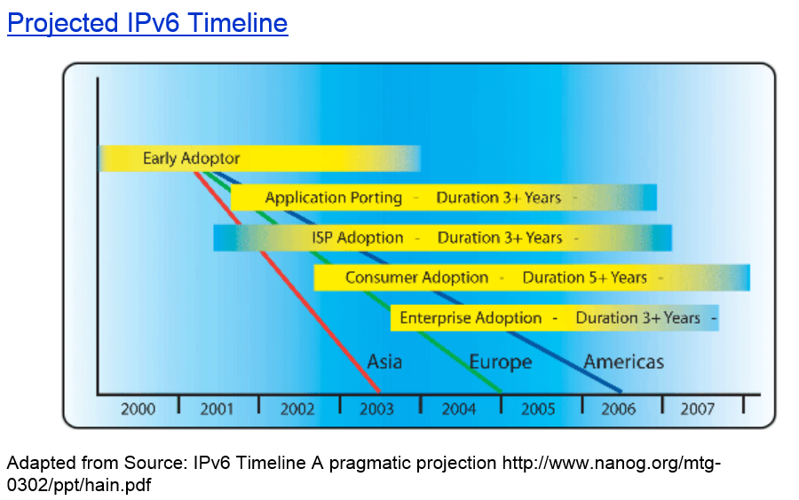

*The timeline for IPv6 is depicted in the image shown above. It shows three regions of implementation: Asia, Europe, and the Americas. Beginning in 2000 by early adopters, it progressed with durations as shown, through application porting, ISP adoption, consumer adoption, and enterprise adoption* (Das, 2012)*.*

*The schedule slip was apparent because it wasn’t until 2005 that a joint project between Lumeta Inc. and the IPv6 Forum (world-wide consortium of leading Internet vendors, industry subject matter experts, and research & education networks formed with the mission to drive IPv6 deployment) was taken up to study IPv6 deployment at the global level. I believe much was underway because the study’s findings indicate that the IPv6 core is well supported, has proven interoperability, is being deployed in the latest generation of routers and operating systems, and is being extended to the last-mile infrastructure necessary to support complete enterprise transitions. Additional standards are being tested and deployed in new IT infrastructure. The integration of IPv6 into enterprise applications, network management, and security infrastructure is already in progress by governmental initiatives in Asia and the U.S* (Das, 2012)*.*

# References

Das, K. (2012, June 6). *IPv6 - The History and Timeline.* Retrieved from IPv6.com - The Source for IPv6 Information, Training, Consulting & Hardware: http://ipv6.com/articles/general/timeline-of-ipv6.htm